Updating the form type component JSON structure for new rating scales

Prerequisites
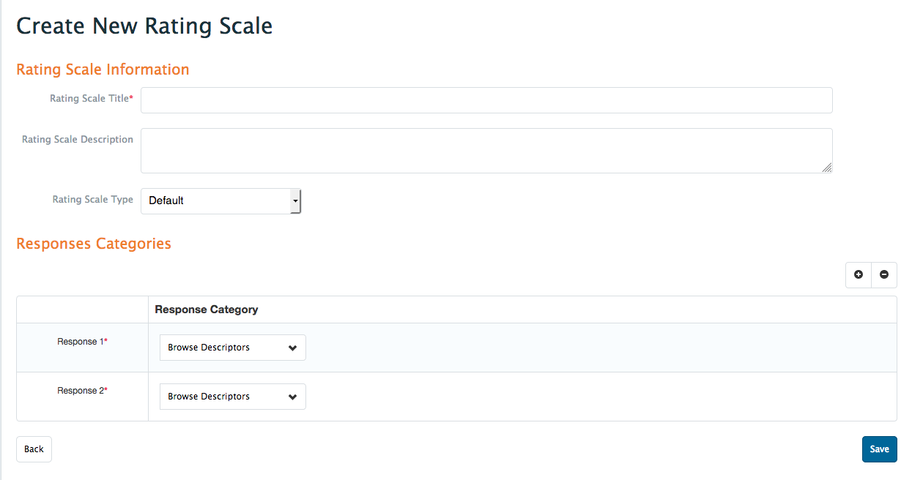
- In order to add a new scale to your system you must have the scale created via the scale bank interface. Admin Assessment & Evaluation Rating Scales Add Rating Scale
- Fill in the rating scale information (including all of the responses) and save the scale.
- You must also know what form types (PPA, Rubric/Flex, Procedure etc.) you would like this new scale to apply to. Write down the form_type_id of each of the relevant form types. (Use table cbl_assessments_lu_form_types.)
- Finally, you will also need the text that will be displayed above the scale, referred to as the item text.

Updating the JSON
- First thing to do is to make note of the new rating_scale_id you just created from saving the scale. You can find this by looking in cbl_assessment_rating_scale and searching for the scale. Once this is found, make note of the primary key value of the record (rating_scale_id).
- Next you want to open up the table cbl_assessments_form_type_component_settings. Here you will see a list of component settings for each form type. This is where we will update the JSON.
- For every form_type_id that is relevant for this new scale we want to edit the settings column, which contains the JSON structure.
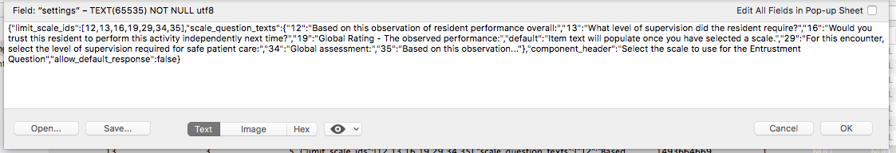
- Some form types will have multiple rows in this table so make sure when editing the settings column that there is already a key in the JSON called “limit_scale_ids”
- To add the scale to the selected form_type_id we simply add the rating_scale_id that we noted in step 1 to the list of “limit_scale_ids”.
Example:
If our sample rating_scale_id is 50 then:
“limit_scale_ids”:[10,11,12,13]
becomes
“limit_scale_ids”:[10,11,12,13,50]
- Then we add the item text for this new scale in the “scale_question_texts” portion of the JSON.
Example:
If our new scale text is “Sample scale text” then:
"scale_question_texts":{"10":"sample text 1”, "11":"sample text 2”, "12":"sample text 3”, "13":"sample text 4”}
becomes
"scale_question_texts":{"10":"sample text 1”, "11":"sample text 2”, "12":"sample text 3”, "13":"sample text 4” , "50":" Sample scale text”}
- Then you can save the settings column with the changes that were just made, and you should see the newly added scale as a choice when adding scales to a form (for the form type that was edited). Repeat these steps for every form type that you would like the scale to apply to.

