Installing Data Governance
- Install Integration Server and Centerprise Data Integrator by clicking on the installers one by one.
- This will install both client and server and also host Data Governance here: http://localhost:9462/ OR http://<machinename>:9462/
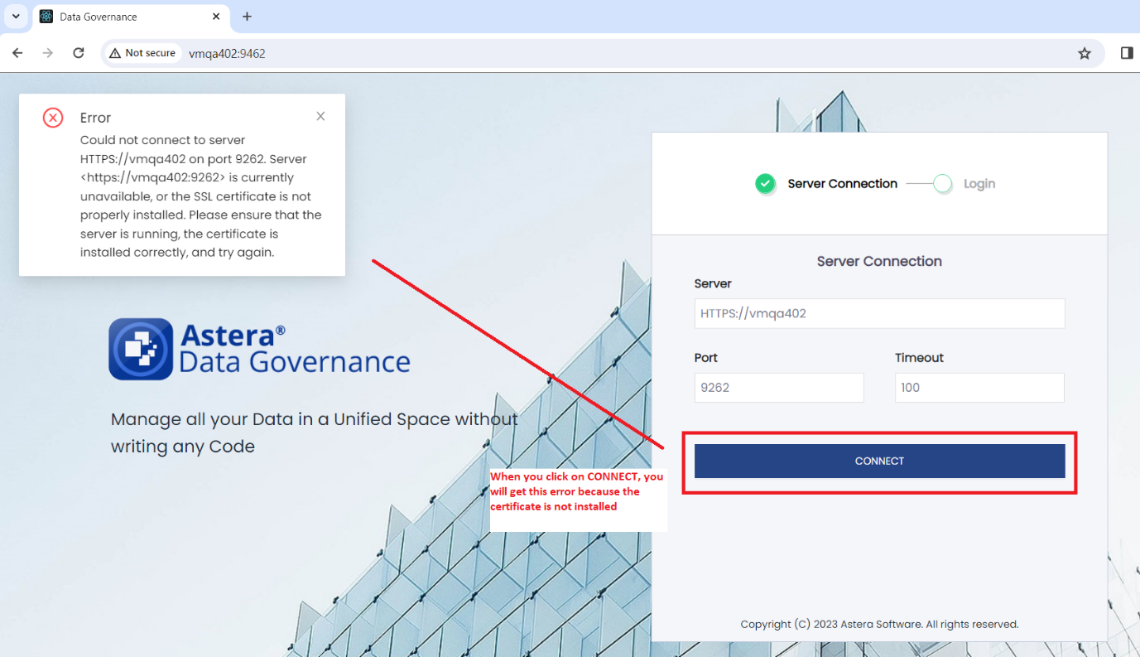
- When you try to connect to the server, you will get this error although the service is running because the SSL certificate is not currently installed.
- There are 2 ways to bypass the SSL certificate error:
- The first way is to open the URL below on the browser and follow the given steps:

- Open Browser go to https://localhost:9262/api/ in order to install the certificate and proceed.
Note: If you want to use the machine name instead, replace 'localhost' in the URL with your machine's name. Example: https://vmqa402:9262/api/

- Click on ‘Advanced’:
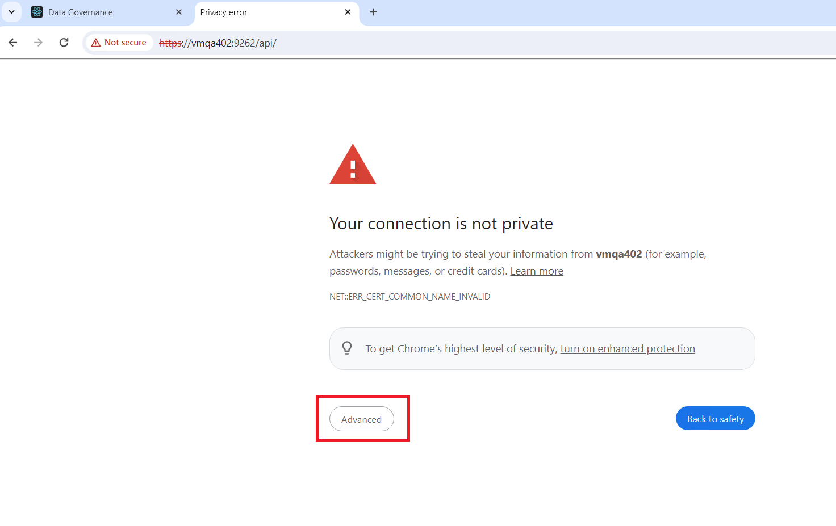

- Click on ‘Proceed to vmqa402 (unsafe)”:
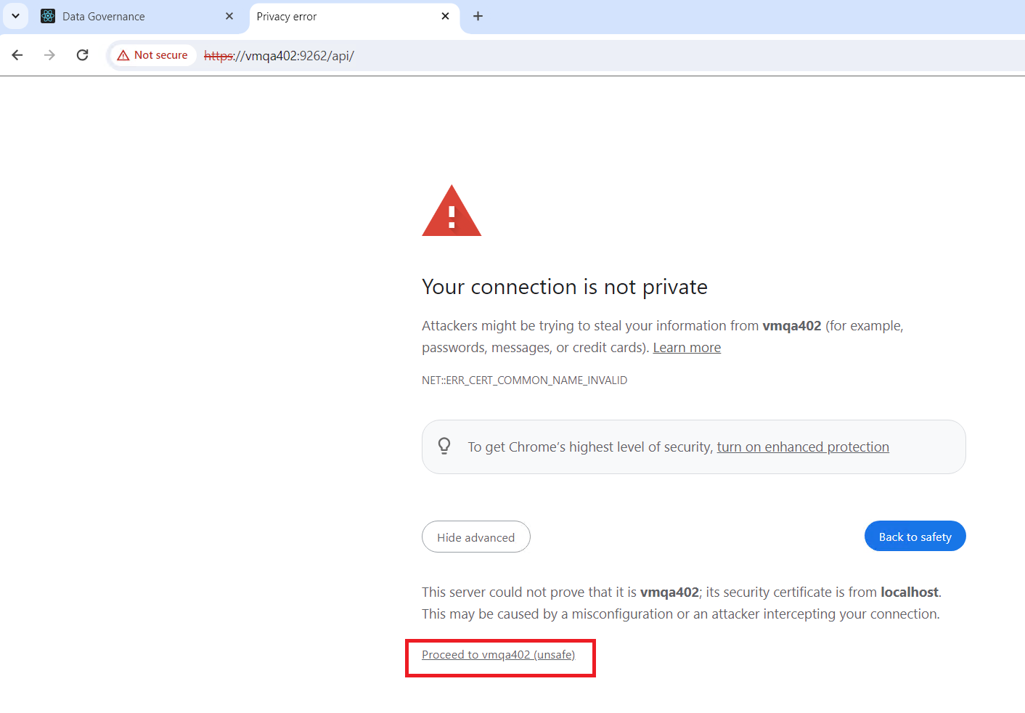

- You will see the following response:
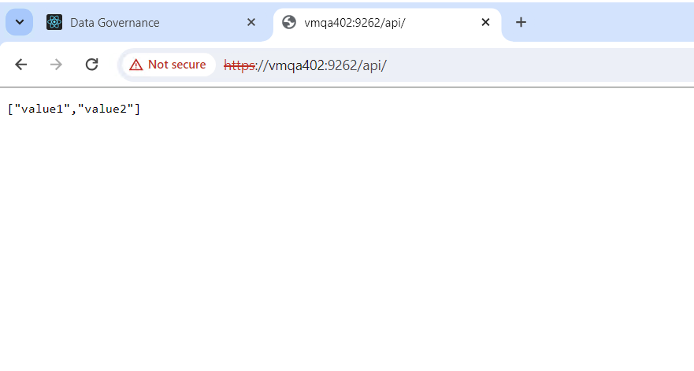
- You should now be able to connect to the server and proceed to the login page. Please make sure that the database repository is configured in order to log in:
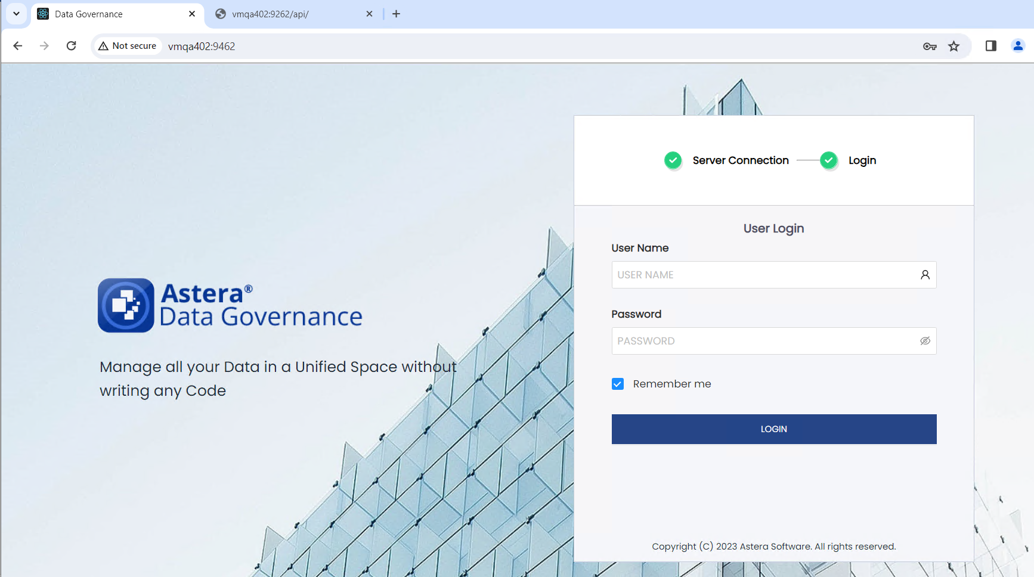
Note: For each browser, you will have to hit this URL if you have the browser running on the same OS as the Integration server in order to proceed: https://localhost:9262/api/. If the browser runs on a different OS then you can enter that machine’s name in the URL (https://vmqa402:9462/api/).
Also, if you are using Firefox browser then only this approach will work, not the second one.
- The other way is to import the SSL certificate in ‘Manage user certificates’ and proceed:

- Open ‘Manage user certificates’ from Start menu:
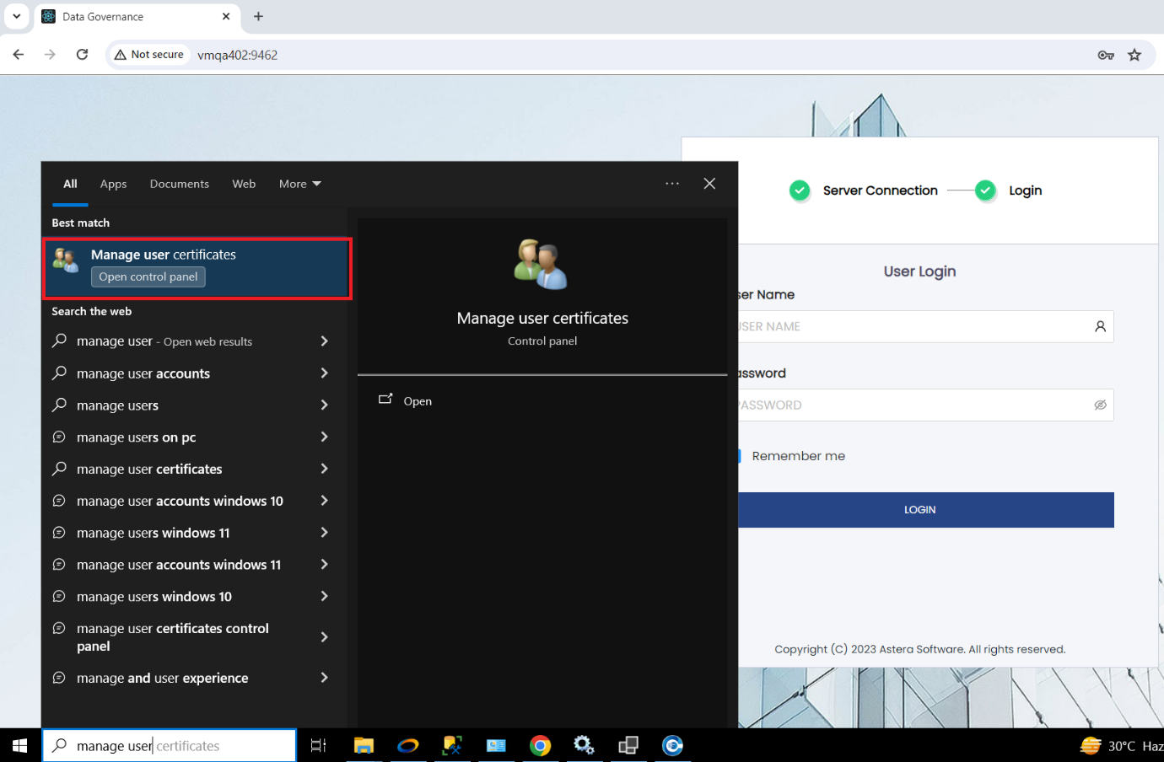

- Go to ‘Trusted Root Certification Authorities’, go to ‘Certificates’ then go to ‘All Tasks’ > ‘Import’:
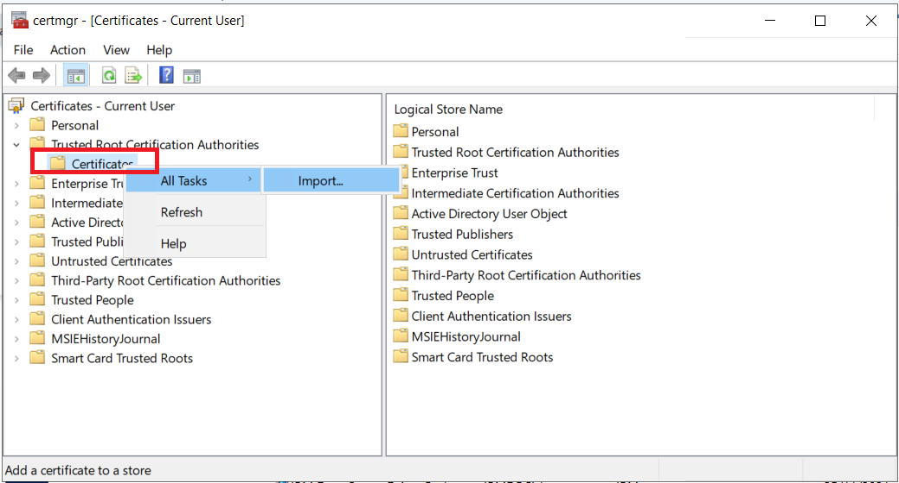

- Click on ‘Next’
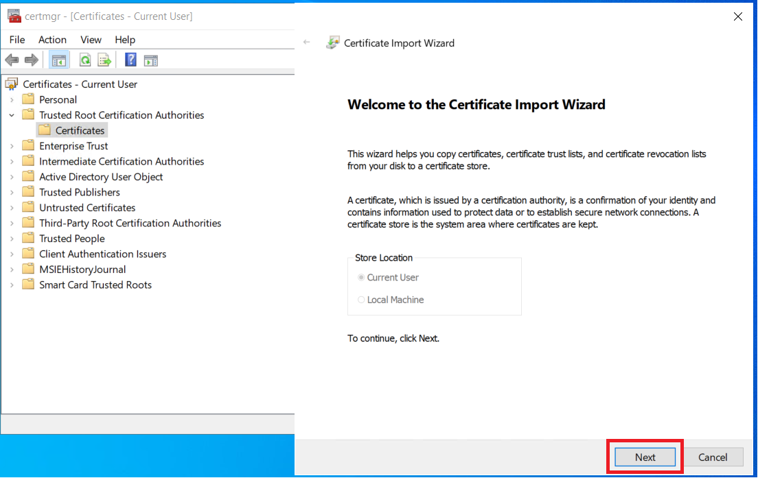

- Browse the certificate from here \\astera.com\share\general\Sanober\SSLCertificate\certificate.pfx and add it:

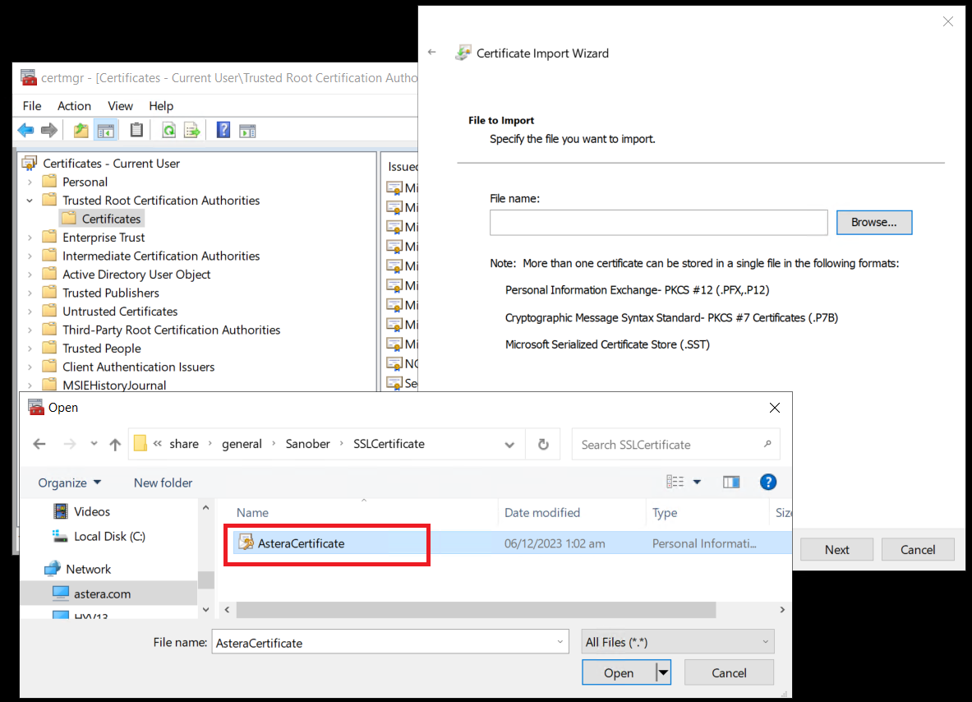

- Click on ‘Next’:
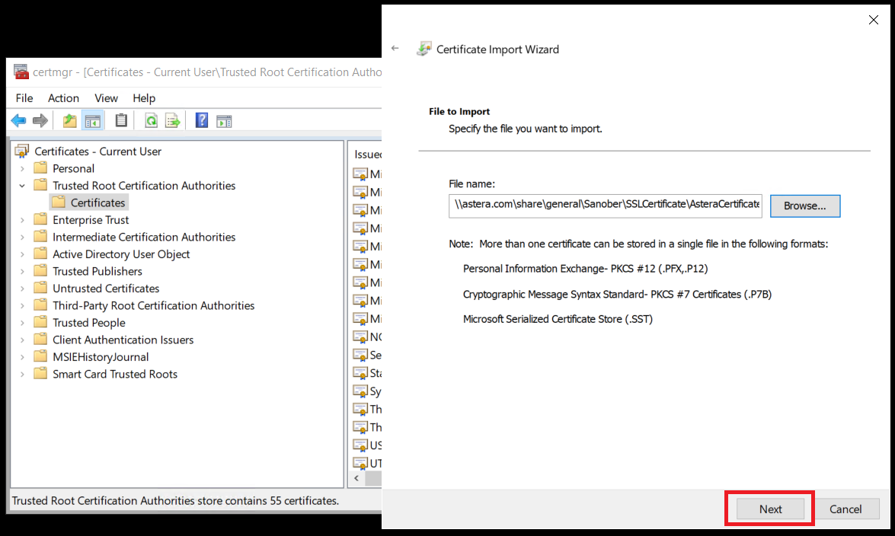
- Enter the private key for the certificate which would have been set by the certificate owner, in this case ‘Astera’. The password is “Astera123” and click on ‘Next’:
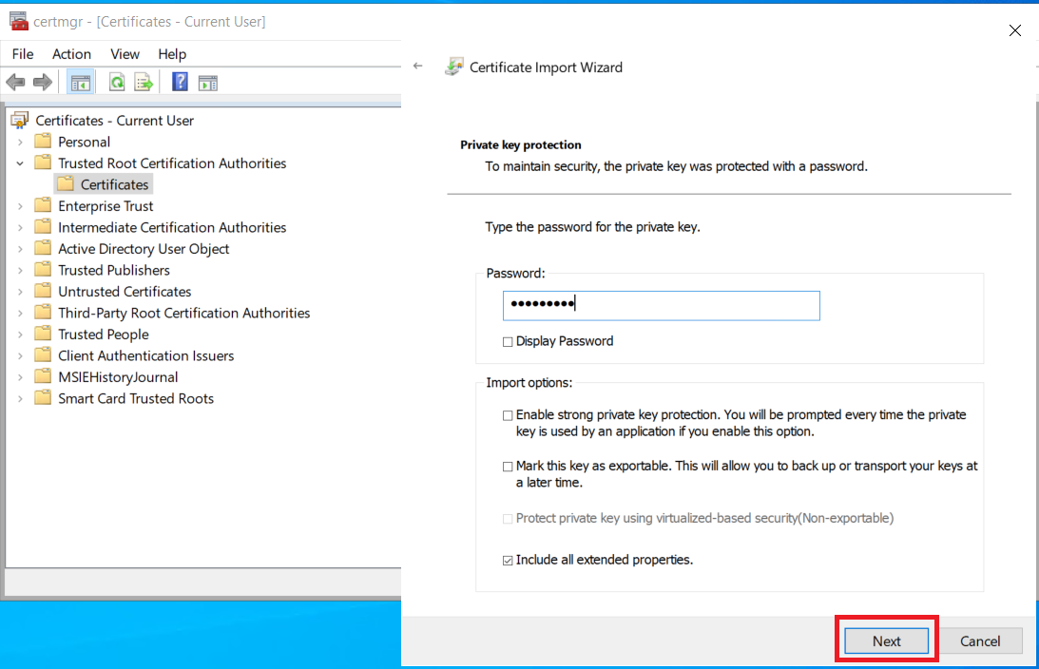
- Click on ‘Next’:
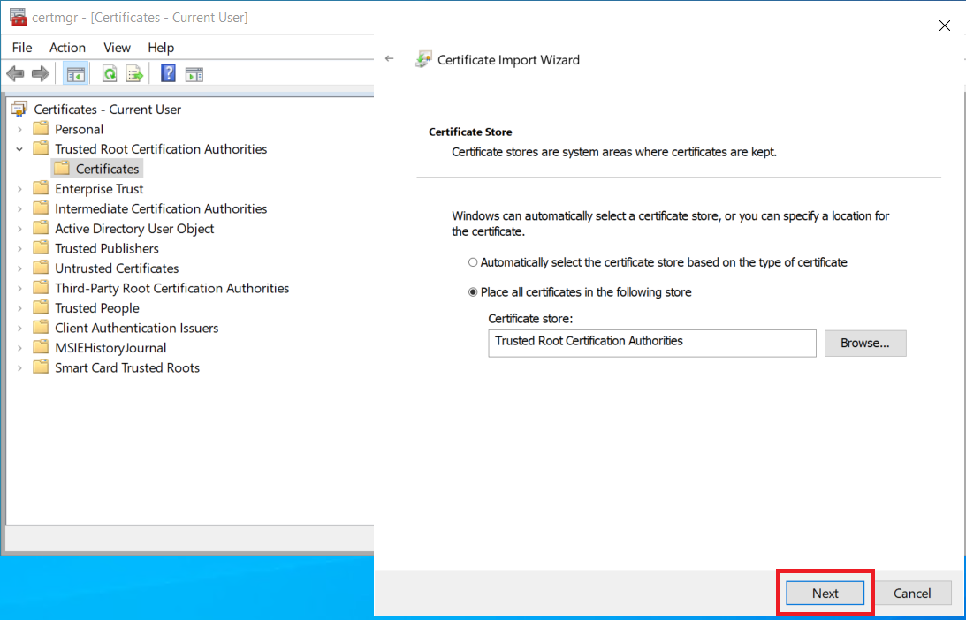

- Click on ‘Finish’:
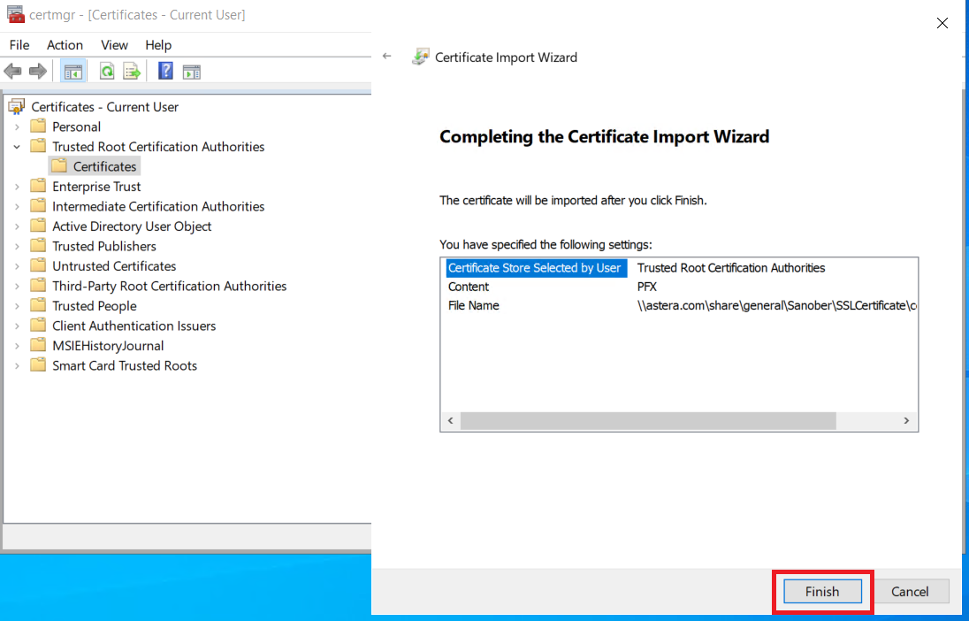
- Close and relaunch the browser, you should now be able to connect to the server and proceed to the login page. Please make sure that the database repository is configured in order to log in:
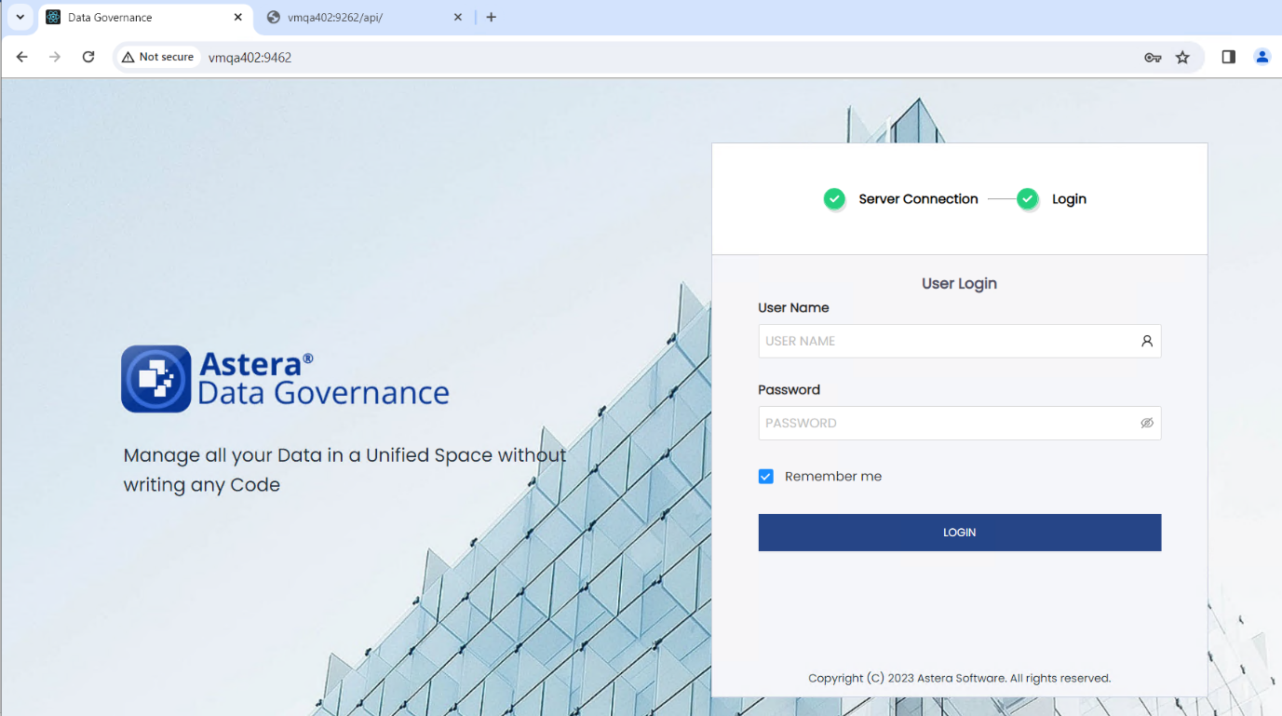
Note: The second approach (certificate installation) does not require you to do it for every browser. However, this will be required for every OS that you are using for data governance.

